In order to achieve accurate classification from the Akida model, we need to train it on realistic images, thus giving it simulated weather conditions.
For the first iteration I added basic filters like gaussian noise, motion blur, defocus blur, and jitter.
Reference image:
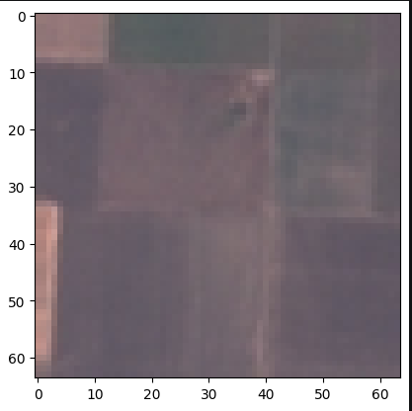

1. Gaussian Noise
Gaussian Noise can be experienced because of the electronic gain. Bumping up the camera's sensor gain physically introduces electrical static (grain) into the image. Extreme cold (- 60C in the stratosphere) can also cause battery voltage drops that increase sensor noise.
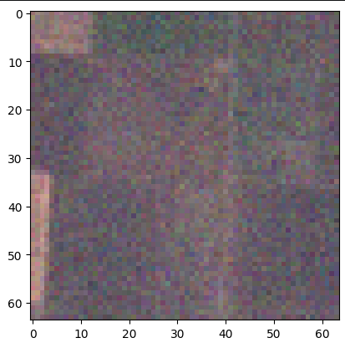

2. Motion Blur
If the payload box is spinning or swinging on its tether in high stratospheric winds, the camera is moving laterally. This is compensated by the SHUTTER_US variable in the camera code. which freezes most of the motion
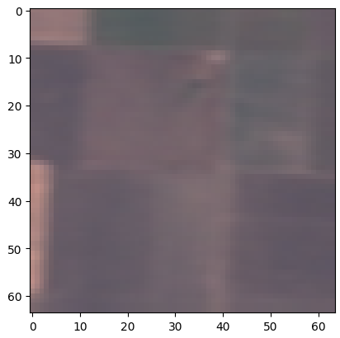

3. Defocus Blur
The camera lens is going to experience temperatures varying between +30C on the launchpad to -60C in the tropopause. Lenses mathematically shift their focal plane as the glass and plastic barrels contract in the cold so we are risking micro-condensation or frost forming on the outside of the payload lens casing.
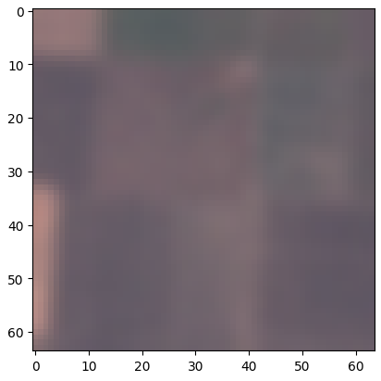

4. Jitter (Brightness & Contrast)
Without a thick atmosphere above the satellite to scatter and soften the sun rays, direct sunlight bouncing off a lake, a tin roof, or a cloud layer will overload the camera sensor (overexposure). Conversely, if the payload swings and the camera points into the shadow of the balloon itself, the image will instantly darken (underexposure).
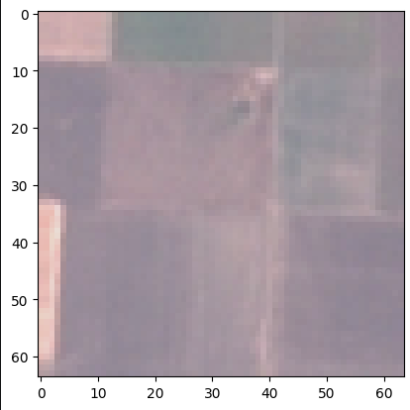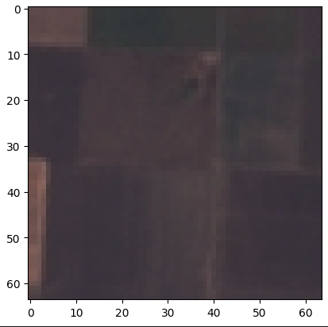
Now I will be trying to simulate realistic conditions like sun glare, cloud coverage, etc.
6. Rayleigh Scattering
Looking down through 20-30 kilometers of atmosphere washes out terrain colors and significantly flattens contrast.
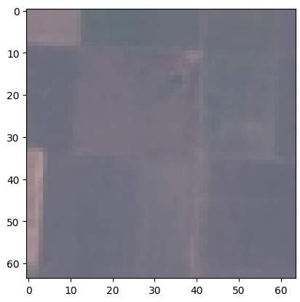

7. Sun Glare (Lens Flare)
Because there is less atmosphere to scatter the sun light, rays hitting the camera lens create harsh, directional flares and massive overexposure.
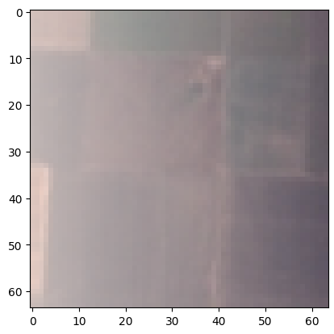

8. Cloud Coverage
Spatial masking, simulating bright white patches physically blocking the terrain.
